Lab # 5

Subject: CPS-410 Operating System Course: BESE 14 A & B
Instructor: Nausheen Date: October 25, 2010

TASK

Consider a multiprogramming system where multiple processes (jobs) are in the main memory. In order to give each process some portion of the processor time, the system generates interrupt after fixed time intervals say 5 seconds. As a result, control from the running processes is taken and given to the next scheduled job.
The process model considered is a two state model where a job can be either ready (in Queue) or running (using processor). The following figure shows the system design.
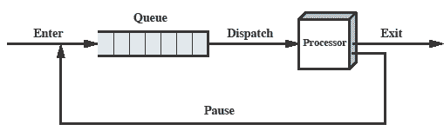
Inputs:
Take five different processes from the user consisting of process ID and total time required for execution.
Output:
The program should print ID and Remaining Time of the Running Process after every 5 seconds.

